

**YOUR AGENCY HERE**

(Indicate Event Title **[example** **“Agency Costume Contest”]** with your donation):

**VISIT** <https://igfn.us/form/pGLKQQ>

**SCAN** the following QR Code

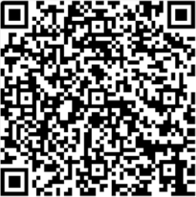

**TEXT** “**givingstate”** to **41444** to receive a direct link.