

**YOUR UNIT HERE**

(Indicate Event Title **[example** **“Unit Costume Contest”]** with your donation):

**VISIT** <https://igfn.us/form/Mev-lQ>

**SCAN** the following QR Code

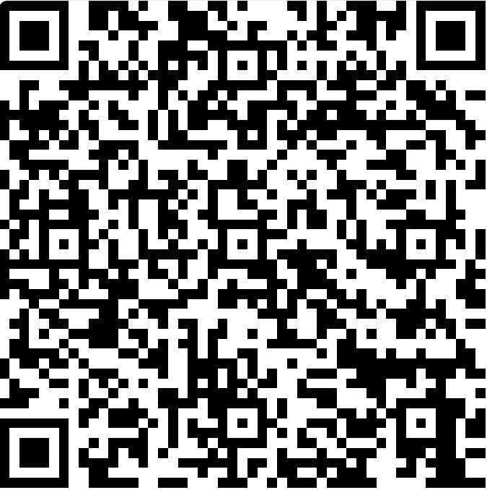

**TEXT** “**givinguw”** to **41444** to receive a direct link.