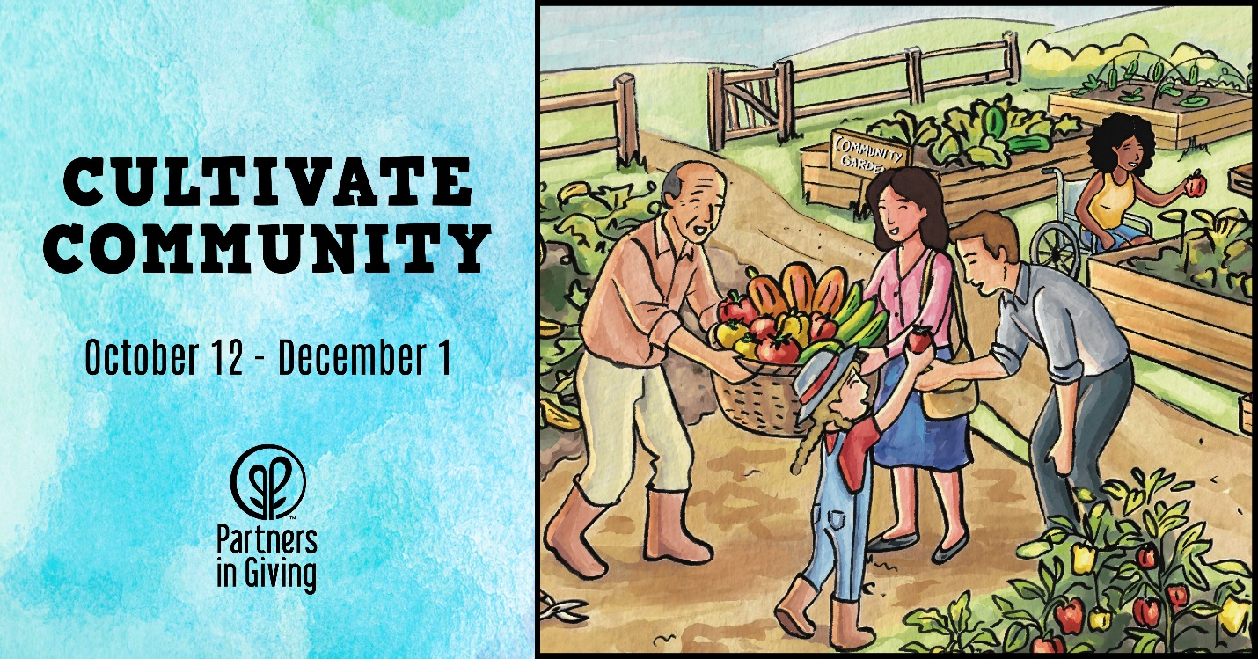
YOUR UNIT HERE
(Indicate Event Title [example “Unit Costume Contest”] with your donation):
VISIT https://igfn.us/form/_EfmKg
SCAN the following QR Code
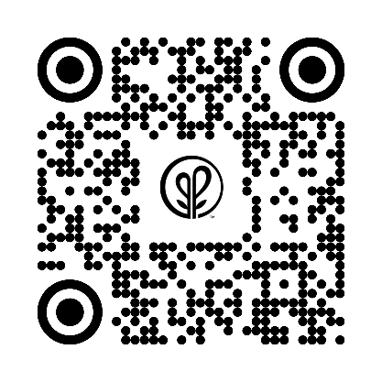
TEXT “givinguwhealth” to 41444 to receive a direct link.

